

**Sensor Fusion Algorithm Software**

**User Guide**

SYSC5709F [35794]

Advance Topics in Software Engineering

**Authors:**

**Shreya Taneja:** [**shreyataneja@cmail.carleton.com**](mailto:shreyataneja@cmail.carleton.com)

**Ankit Kumar Vig:** [**ankitvig@cmail.carleton.ca**](mailto:ankitvig@cmail.carleton.ca)

Table of Contents

**User Guide** 1

**Sensor Fusion Algorithm** ………………………………………………………………………………1

Advance Topics in Software Engineering 1

**Sensor Fusion Algorithm**

In view of the uncertainty of data in multi-sensor sample system, a simple algorithm of determining the integrated support degree of each sensor based on principal component analysis is proposed. The algorithm defines the fuzzy-index function as support degree matrix of sensors. By principal component analysis, each sensor’s integrated support degree score is obtained. According to their scores, valid observation values of sensors are determined and fused by allocating corresponding weight coefficients, so that the final expression of data fusion and estimation is obtained. The algorithm needs less calculation and can objectively reflect the mutual support degree of sensors without knowing any prior knowledge. Simulation shows that the proposed method not only has higher fusion precision compared with other methods, but also has excellent ability against disturbance.

**Installing Cygwin, GCC**

**Windows - Installation**

1. Create the folder C:\cygwin64

2. Visit <http://www.cygwin.com/>.

Look for the section "Installing Cygwin" and select the appropriate version (32 bit or 64 bit) for your PC. In this example, we will show how to install the 64-bit version.

Download the setup file chosen in **C:\cygwin64**. Based on the OS version we will get a file named setup-x86_64.exe (64-bit installation) or setup-x86.exe (32-bit installation)

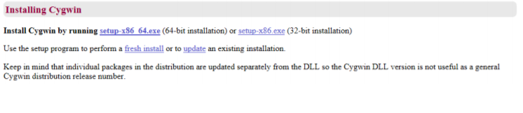

3. Execute setup-x86_64.exe (64-bit installation) or setup-x86.exe (32-bit installation) and click on “Next >”. We will see the following welcome screen.

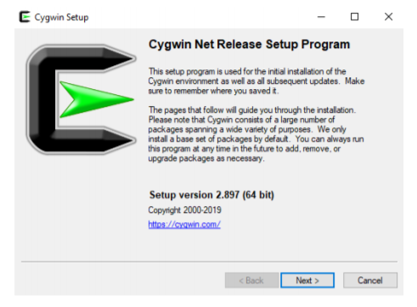

4. Select the option "Install from Internet" and click on “Next >”

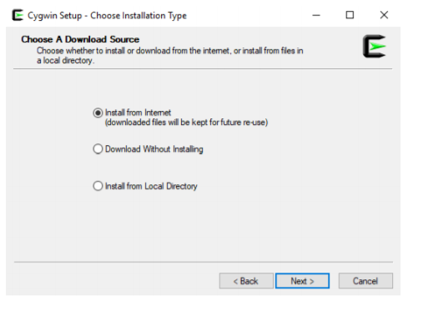

5. We need to select the Root Install directory for storage of Cygwin files. Choose the default (c:\cygwin64, as seen in the screenshot, and “All Users (RECOMMENDED)”. Click on “Next >”

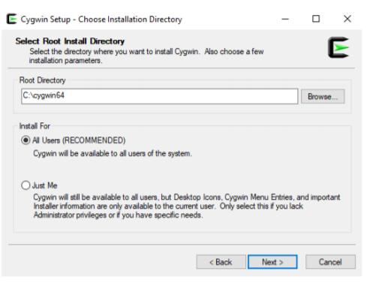

6. Choose your preferred directory for storage of Cygwin local package directory as in the screenshot (i.e. the folder we just created) and click on “Next >”

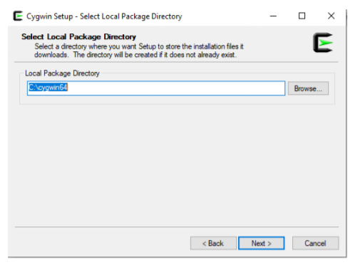

7. Select the option “Use System Proxy Setting” and click on “Next >”.

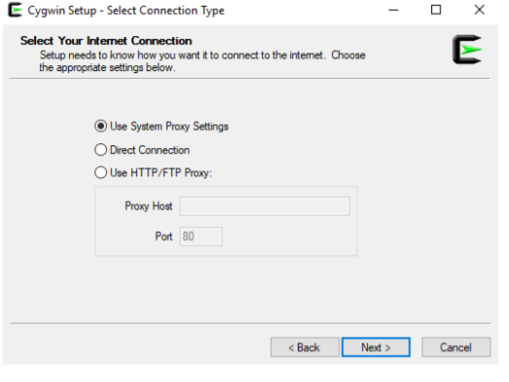

8. After a few seconds, the following window will appear. Choose a Download Site as in the screenshot. Click on “Next >” (in this case, <http://cygwin.mirror.constant.com>)

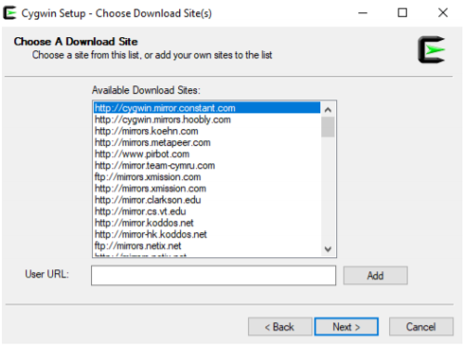

9. Cygwin will start the installation process. The following window will appear.

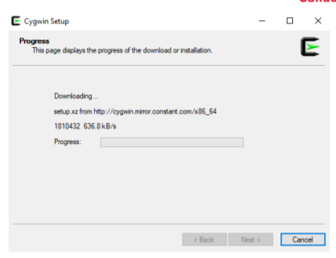

10. When we get the following window, if we click on “All”, we will see all the existing packages. Do not choose anything; simply click “Next >” leaving everything as default (as in the screenshot).

This will install the default tools and libraries.

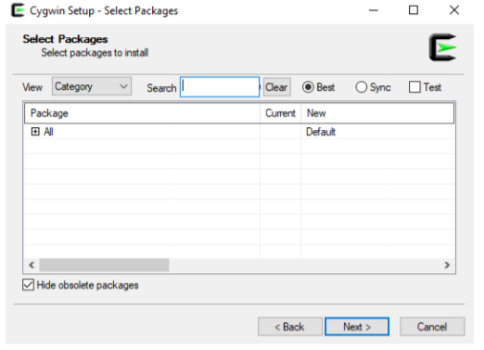

11. The following window will appear. Click on “Next >”

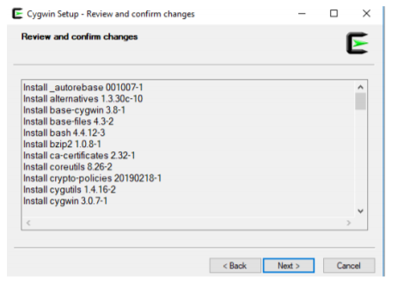

12. The progress window below will appear.

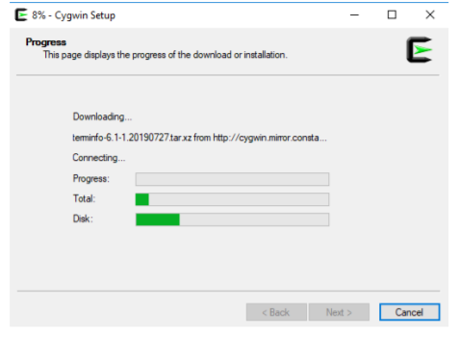

13. Once the installation finishes, select the option “Create icon on Desktop” to easily access the Cygwin terminal. Click on “Finish”

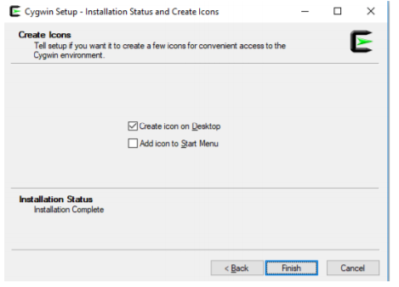

14. Once the installation finishes, if we open the cygwin64 folder, it should have the following content.

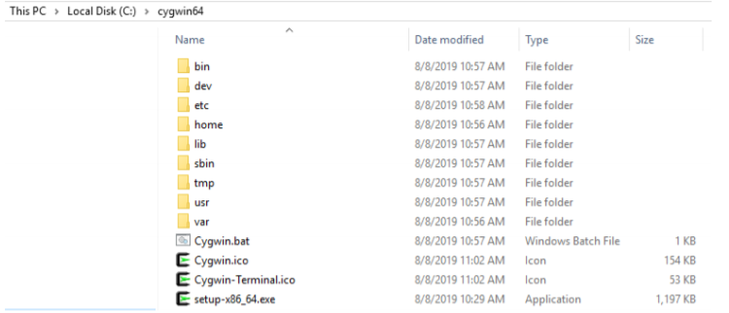

15. Open the windows terminal (Command Prompt; type “cmd” on your Windows search). Type cd c:\cygwin64

For the 64-bit installation, type:

setup-x86_64.exe -q -P chere -P wget -P gcc-g++ -P make -P diffutils -P libmpfr-devel -P libgmp-devel -P libmpc-devel -P git

(For 32-bit installation, replace by setup-x86.exe)

It will install all the necessary libraries and the last version of gcc/g++ compiler.

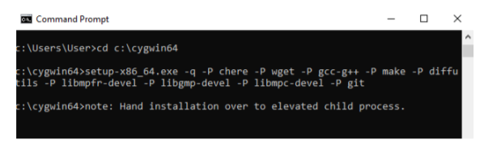

16. A Progress window will pop up while all the required packages along with their dependencies are downloaded and installed, as in the following screen capture.

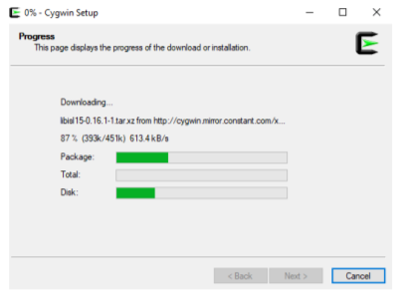

The installation process will take several minutes. Once the installation process finishes, the window will disappear automatically, and we can close the Command Prompt.

17. Run Cygwin on your desktop, in administrator mode (right-click on the desktop icon and select the option “Run as administrator”; we can also use c:\cygwin64, and run the script “cygwin.bat” in Administrator mode).

The skeleton files will be created.

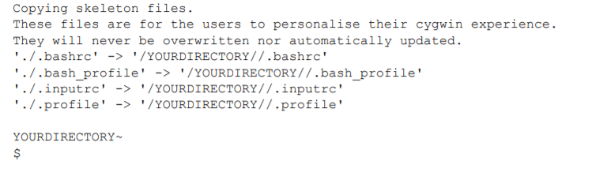

18. Type the following command on the terminal and press “Enter” (in this case, we show an example for user “User” running Cygwin on the Desktop):

wget rawgit.com/transcode-open/apt-cyg/master/apt-cyg

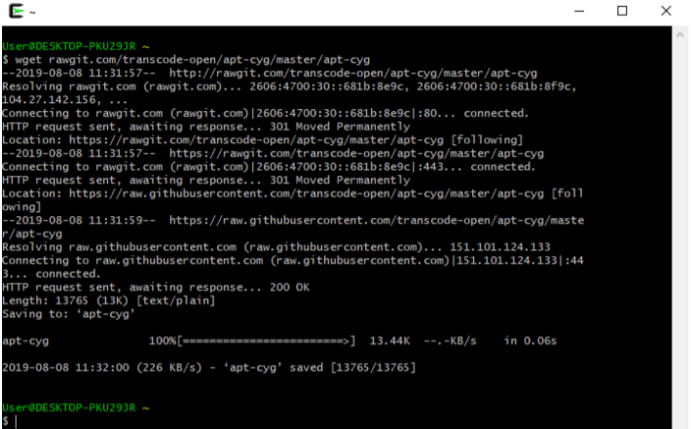

19. Type the following command and press “Enter”

install apt-cyg /bin

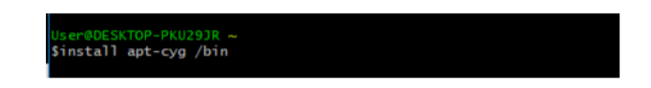

"apt-cyg" is a command in Cygwin similar to the "sudo apt-get" command in Linux. It is used to install packages, update them, list them, etc.

20. Type the following command and press “Enter”

chere -i -t mintty -s bash

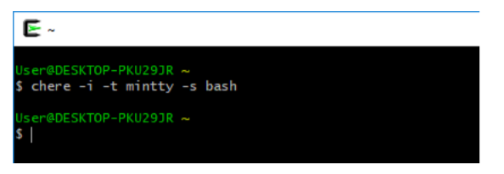

This will allow us to open a Cygwin bash terminal from any folder in your Windows File Explorer or other applications.

21. Type the following command on Cygwin terminal and press “Enter”.

apt-cyg install libboost-devel

This installs the Boost Library. A progress message will show the installation.   
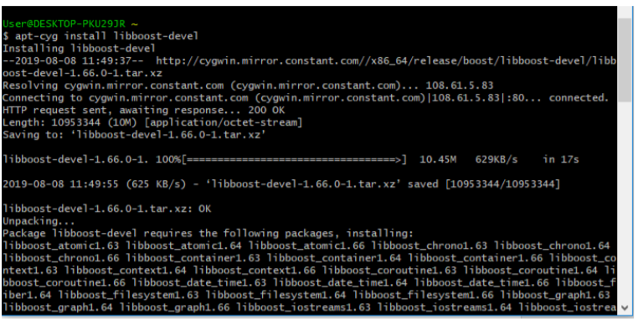

22. The next step is to install GSL library for Sensor Fusion Algorithm Software. Type the following command:

apt-cyg install gsl-devel

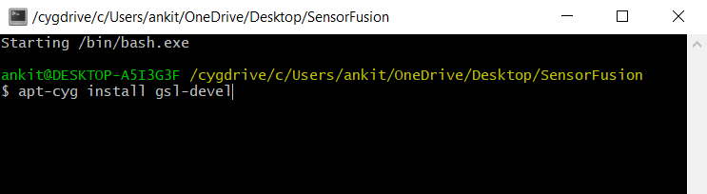

This will install GSL library. A progress message will show the installation.

**Downloading the Sensor Fusion Algorithm Software**

1. Install Git(User can use Git bash or any other software of choice to clone the project).
2. Create a new folder for the project. Right Click inside the folder and open a git bash here. Right Click + ”Git Bash here”.
3. Type the following command in the git terminal:

Git clone <https://github.com/shreyataneja/SensorFusionAlgo.git>

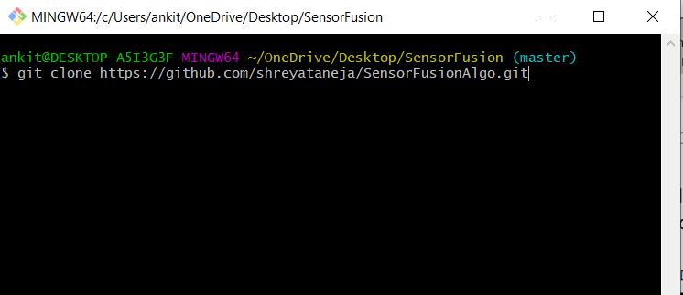

1. Or go to the link <https://github.com/shreyataneja/SensorFusionAlgo> and click on **Clone or Download** and download the zip folder of the software.

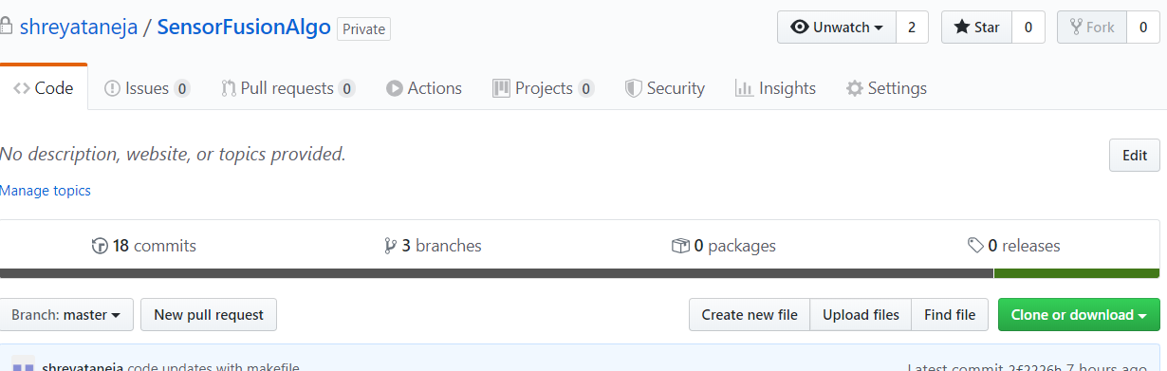

**Compiling and Running the Sensor Fusion Algorithm Software**

To compile and run the tests for the software, follow these steps:

1. Compile the project
2. Open the folder containing the cloned or downloaded software from git.
3. Open Bash Prompt inside the folder i.e. Right Click + ”Bash Prompt here”.
4. To compile the project, type in the bash prompt :

Make clean; make all

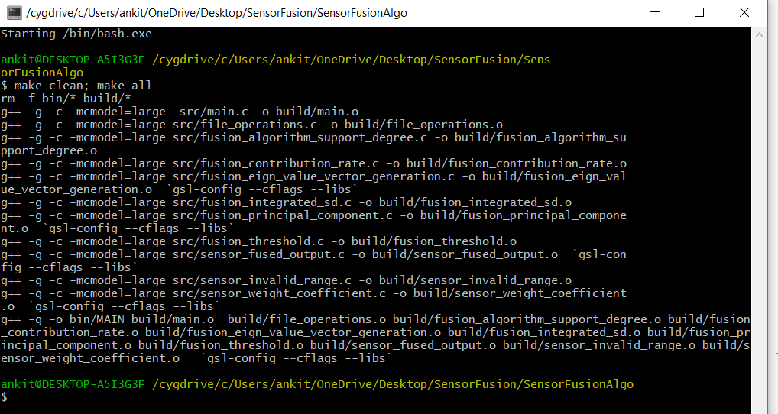

1. Run the software and test with input file of your choice. Place the input file in the inputs_and_results folder.
2. From the previous command, you now have new folders created , i.e. bin and build , the tests will run in the bin folder .

Type: cd bin

1. To run test with input file of your choice, for example, input_sensorfusion.csv, type:

./MAIN.exe ../inputs_and_results/test_input_1.csv

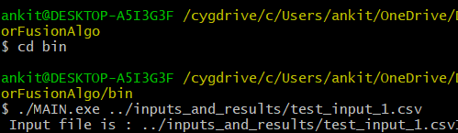

1. To run the software with different input files, simply create a .csv file with desired inputs and replace in command with new file name
2. The output file will be created in **same folder as of the input file** in the following format: inputsfolder/inputfilename_output.csv

Example:

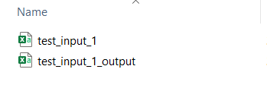

**\*\* NOTE:** The complete folder structure, code and the documentation is available in the git repository –

<https://github.com/shreyataneja/SensorFusionAlgo>

And,

<https://github.com/AnkitVig/SensorFusionAlgo>